בס" ד
TLS Class Exercise (Barak Gonen):
I. TLS v1.2 handshake
Open the snipping file TLS12sniffEx.pcapng.
- How many packets contain Client Hello? What is the filter that allows you to find packets of this type only? 42 packets. Filter - tls.handshake.type == 1
- Focus on the first Client Hello packet. What is the domain name to which you are browsing to?
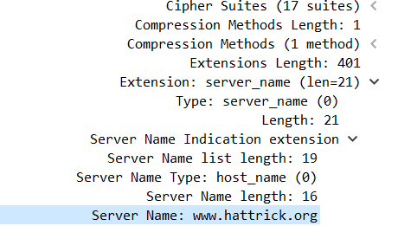

- What filter can be put in Wireshark to receive only the Client Hello, which is intended for a Server Name of our choice? tls.handshake.extensions_server_name == www.hattrick.org
- What is the TLS version?
- What is the Cipher Suite (קבוצת צפנים) chosen by the server? What algorithm is used for the following operations?
I right-clicked on the client hello - follow tcp stream entry and accepted filtering for the conversation between the client and the server. I looked for a server hello packet and there I saw the Cipher Suite that the server had chosen.
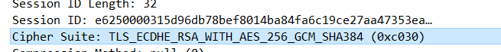

a. Hashing - SHA-384
  - Encryption – AES-256-GCM
  - Authentication - RSA
  - Key Exchange - ECDHE
- How many certificates are sent by the server? What is their common name?
2 certificates

- Is the certificate also valid for other URLs that are under hattrick.org? yes, If *.hattrick.org appears, the certificate is a Wildcard and is valid for all subdomains under the main domain.
- Between which dates is the hattrick.org certificate valid? 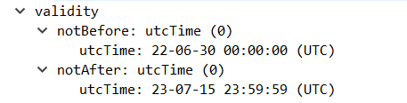
- Who is the Root Certificate Authority and was his certificate sent to the client?
The Root Certificate Authority does not appear because it already appears in the browser and is known to everyone.
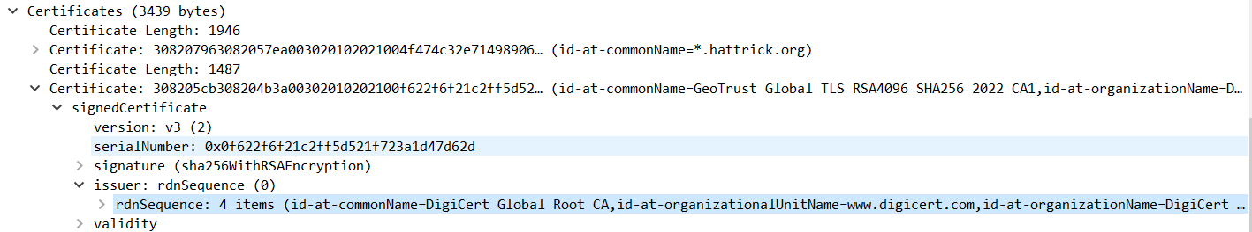
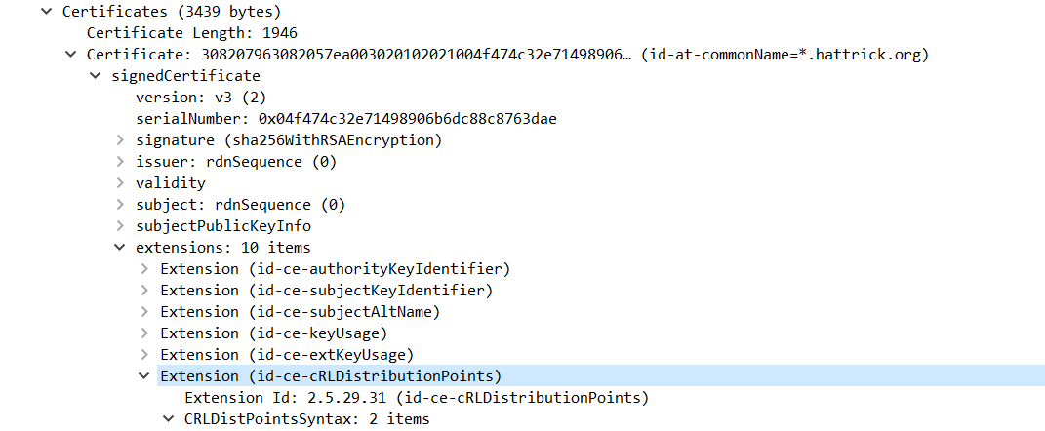
- How does the customer verify that the hattrick.org certificate is not revoked? Is it through the Certificate Revocation List, through the OCSP protocol (Online Certification Status Protocol) or through OCSP Stapling? 1. Certificate Revocation List 2. OCSP

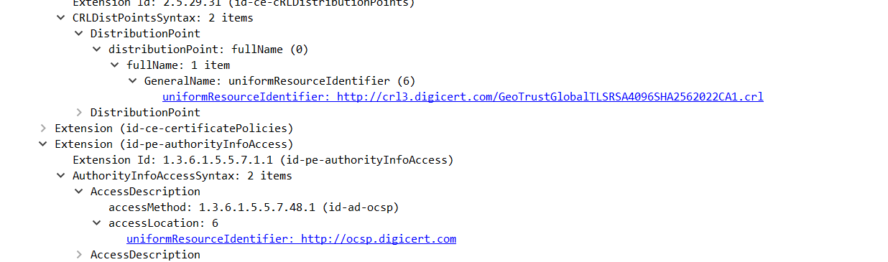

- Which Record is sent from the server to the client and would not have been sent if the key exchange was with the RSA algorithm? What does this record include when it is sent?
- What is the handshake type of the Client Key Exchange and what does it include? Does the customer sign it?
- Use the SSL log file to decrypt the encrypted information. How can wireshark pick a specific set of keys, from all the keys in the file, which is the correct key set for the TLS session? There is a value which appears both in the sniffing and in the Wireshark log. What is the name of that field, in wireshark?
- What is the first resource that the client does a GET for? What is the received status code?
Explain what the customer will do as a result.
- Follow TLS Stream. In the search screen, search for Username and Password.
T L S e x e r c i s e P a g e 1 | 2

II. TLS v1.3 Handshake
Open the snipping file TLS13sniffEx.pcapng . Find the stream associated with jct.ac.il.
Client Hello:
- What version exists in the Record Layer Header? What version exists in the Client Hello Version field?
- What are the first 6 hex digits of the Client Random number?
- What are the first 6 hex digits of the Session ID?
- How many Cipher Suites did the client propose?
- Which Cipher Suites are TLS 1.3?
- Use the Extension “Key_Share”. Which Diffie-Hellman curves are chosen by the client?
- At this point, does the client know that this DH curve is supported by the server?
Server Hello:
- What version exists in the Record Header? What version exists in the Server Hello Version field?
- What are the first 6 hex digits of the Server Random number?
- What are the first 6 hex digits of the Session ID? How does it compare to the client Session ID?
Why?
- Which Cipher Suites did the server choose?
- Use the Extension “Key_Share”. Which Diffie-Hellman curve is chosen by the server?
- Did the client guess correctly? What would happen if not?
Certificate:
Decrypt the TLS communication. There are 3 subfields under “Certificates”. A certificate, an “Extension” and another certificate
- Who holds the first certificate? Look into the “subject” field
- Who issued the first certificate? Look into the “issuer” field
- What is the purpose of the “Extension”? Which protocol is used?
- Who holds the second certificate? Look into the “subject” field
- Who issued the second certificate? Look into the “issuer” field

The End, Good luck!
T L S e x e r c i s e P a g e 2 | 2

